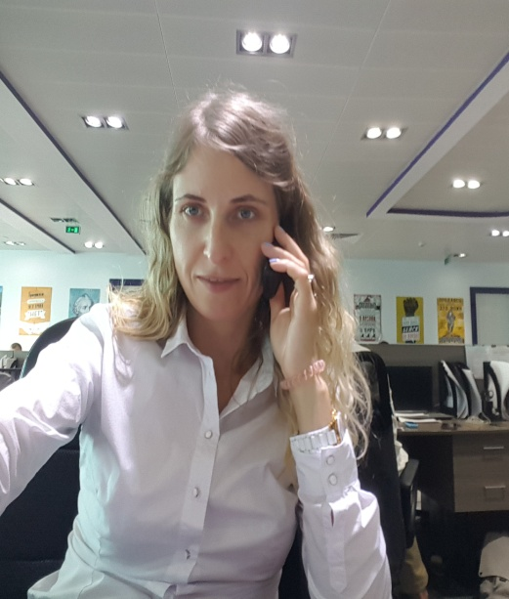

**Curriculum Vitae**

Polina Kravtsova Date of Birth: 16/11/1985

Telephone: + 971566114837

Email: berris462@gmail.com

**EDUCATION**

2003 - 2005 of the year Medical School, city of Valuyki Specialty – nursing, qualification - nurse

2006 – 2012 of the year Institute of Tourism in Hospitality, Moscow Qualification – manager, Specialization - management organization

EXPERIENCE

From April 2022 to August 2024 Real Estate Broker “Penny Realty”

From April 2022 to April 2023 Selfemployed “Beautycian “

From September 2018 to March 2022 Hotel “ Tzargrad" (cosmetologist-esthetician) part time

March 2018 to March 2022 Agency “Point Estate” (broker )

From June 2022 to until now

Study English Jobsplus

From May 2017 to August 2018 Fitness Club «Don Sport», Moscow (cosmetologist – esthetician)

From August 2015 to May 2017 Fitness Club «Olympic Star», Moscow

(cosmetologist-esthetician)

**LANGUAGES**

ENGLISH (fluent), Spanich – elementary

**OTHER SKILLS**

* Computer skills: Excel, Power Point, 1C bookkeeping, Master Tour
* Drawing up a diet of proper nutrition
* Presentation of cervices and development of promotions
* Excellent communication skills
* Good knowledge of Accounting
* Attending business trainings

**INTERESTS**

I like to read books on business, go in for sports - skiing, skating, fitness, big tennis. I also do self-development – I attend online trainings in psychology and personality development.